Part 1: Conceptual Understanding
- Explain in your own words: What is the difference between image classification and object detection?
Using a photo of a bedroom as an example, Image Classification would be identifying that it was bedroom, where object detention would be circling all the objects in the room.
- Bounding boxes: Why do we use fractions (0 to 1) for bounding box coordinates instead of pixel values?
We used fractions (1 to 0) instead of pixel values because we don’t know the size of the object, where if we use fractions we can identify what percentage of the objects size to use.
- IoU metric: Explain what IoU measures. Why is an IoU of 0.5 commonly used as a threshold?
IoU =1 indicates predicted box covered the entire actual box, and IoU = 0 means that the predicted box missed the predicted area. 0.5 is used because it means that the prediction covered at least half of the actual.
Part 2: Implementation Experience
- Visualization function: What was the most challenging part of implementing the display_examples or plot_detections function? How did you solve it?

- IoU calculation: Walk through your IoU implementation. What would happen if you forgot to use max(0, ...) for the intersection width and height?
If max(0,…) wasn’t there, if the boxes didn’t overlap the height or width would be negative.
- Debugging: Did you encounter any errors while coding? What was the error and how did you fix it?
No real errors, just bad results. I had to check with Claude and it told me to swap out an if statement. Details are at the end, too much info to sneak in here.
Part 3: Results Analysis
- Confidence threshold experiment:
  - How many boxes did you see with threshold=0.3 vs threshold=0.7?
0.3 had approximately 20 boxes, while 0.7 had 2 boxes.
  - Which threshold do you think is better? Why?
0.7 is better because there was way too many boxes which because useless with the 0.3
- IoU threshold experiment:
  - How did precision and recall change when you changed the IoU threshold?
As I increased IoU, the precision and recall both dropped, and when I lowered it they both increased.
  - Explain why this happened.
When you lower the IoU, it lowers the bar for what it considers good, and raising it makes it stricter.
- Model errors: Find one example each of:
  - A false positive (model detected something incorrectly)
Jockey labeled as a bicycle and a horse labeled as a tv monitor
  - A false negative (model missed an object)
Missed the horse in the background.
  - Include screenshots and explain why you think the model made these errors.
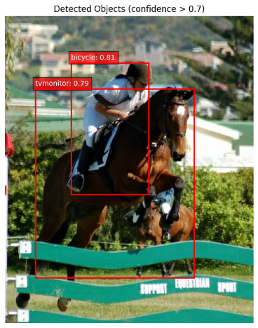
Its possible that the Jockey looks like he is riding a bicycle, similar to the racers. But I have no idea how a horse can look like a TV.
Part 4: Critical Thinking
- Precision vs Recall trade-off:
  - For a self-driving car detecting pedestrians, would you prioritize high precision or high recall? Why?
I would think that recall would be more important then precision. High recall will flag lots of things, but it might not always be correct on what it labels it as. For self driving cars, I think that pointing something out is more important then correctly identifying something. I don’t care if it’s a horse or a tv, the car needs to avoid whatever it is in the road.
  - For a photo app that tags objects in your pictures, would you prioritize high precision or high recall? Why?
I would prioritize high precision, because being correct is more important then the fact you identified something. It would be better to not identify anyone instead of putting someone in like a murder scene who wasn’t there.
- Pre-trained models:
  - What are the advantages of using a pre-trained model?
One major one is speed.
  - What are the disadvantages?
It’s possible you could be dealing with stale data.
- Real-world applications: Name three real-world applications of object detection and explain why object detection (not just classification) is necessary for each.
- Medical Imaging (e.g., tumor detection)
Used in radiology systems analyzing X-rays, MRIs, or CT scans.
- Why detection is needed:
Doctors need to know the exact location of abnormalities (like tumors or lesions).
- Why classification alone fails:
A classifier might say “tumor present,” but that doesn’t help a doctor:
  - Locate it
  - Measure its size
  - Plan treatment or surgery
Detection highlights where the issue is, not just if it exists.

2. Retail & Inventory Management (e.g., cashier-less stores)
Used in stores like Amazon Go.
- Why detection is needed:
Systems must track multiple items and their positions as customers pick them up.
- Why classification alone fails:
A classifier could say “this image contains a soda and chips,” but cannot:
  - Distinguish between multiple identical items
  - Track which specific item a customer picked up
  - Monitor movement over time
Detection enables tracking individual objects in space and time.

- Security Surveillance
Used in surveillance systems from companies like Hikvision or Axis Communications.
- Why detection is needed:
Systems must identify who or what is present AND where they are, often across multiple frames (people, vehicles, unattended bags).
- Why classification alone fails:
A classifier could say “this image contains a person,” but it cannot:
  - Locate the person in the scene
  - Detect multiple individuals
  - Determine if someone crossed into a restricted area
  - Track movement or suspicious behavior over time
Detection enables bounding boxes and tracking → critical for real-time alerts, intrusion detection, and behavior monitoring.

Part 5: Going Further (Optional - Bonus Points)
- F1 Score: Research the F1 score metric. Implement a function to calculate it and add it to the evaluation. What does the F1 score tell you that precision and recall alone don't?
- Other models: Research another object detection model (e.g., YOLO, Faster R-CNN). How does it differ from SSD MobileNet V2?
Feature | YOLO | SSD MobileNet V2 | Faster R-CNN | RetinaNet
Type | Single-stage | Single-stage | Two-stage | Single-stage
Speed | ⭐⭐⭐⭐ (Very Fast) | ⭐⭐⭐ (Fast) | ⭐ (Slow) | ⭐⭐⭐ (Moderate)
Accuracy | ⭐⭐⭐⭐ (High) | ⭐⭐⭐ (Moderate) | ⭐⭐⭐⭐⭐ (Very High) | ⭐⭐⭐⭐ (High)
Backbone | Darknet / CSP-based | MobileNetV2 (lightweight) | ResNet / VGG (heavy) | ResNet + FPN
Detection Method | Grid-based prediction | Multi-scale feature maps + anchor boxes | Region Proposal Network + classifier | Anchor-based + Focal Loss
Small Object Detection | Moderate (improving) | Good | Excellent | Very Good
Compute Requirements | Medium–High | Low | High | Medium–High
Key Strength | Real-time performance | Lightweight / mobile | Maximum accuracy | Handles class imbalance well
Best Use Cases | Video, autonomous systems | Mobile / IoT | Medical, research | Dense scenes (e.g., many small objects)

(With a little help from chatgpt…)

- Your own images: Try running the detector on your own images (if possible). How well does it perform? What types of objects does it detect well vs poorly?
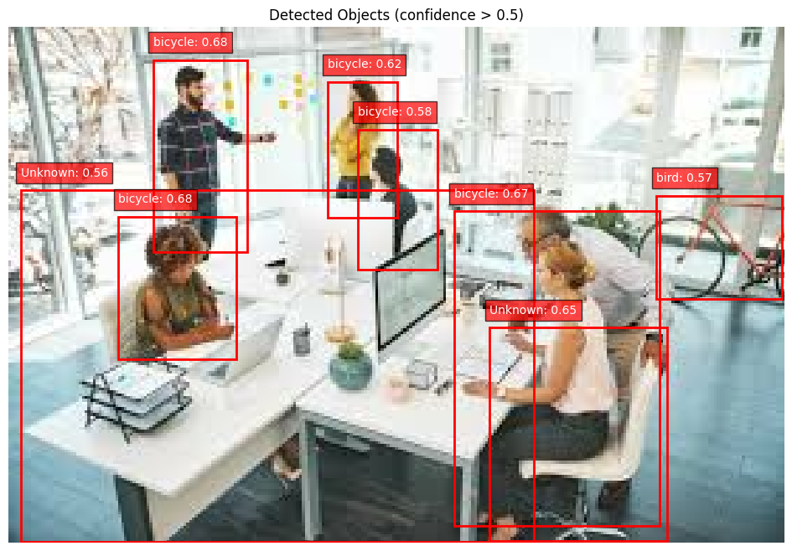
It identified many objects, but accuracy on labeling wasn’t the best. It did find all the people, which it labeled as a bicycle and a bicycle it found that it identified as a bird.

Detail on Question 6
After first run:
Precision: 0.00% (accuracy of detections)
Recall: 0.00% (coverage of actual objects)

Adjusted the amount of training data, from 10% to 99%
train_dataset, train_info = tfds.load("voc/2007", split="train[:99%]", with_info=True)
Same Results:
Precision: 0.00% (accuracy of detections)
Recall: 0.00% (coverage of actual objects)

For the third attempt:
Changed
if pred_labels[i] == gt_labels[best_gt_idx]:
true_positives += 1
matched_gt[best_gt_idx] = True
else:
false_positives += 1 # Wrong class

To
# Just check IoU, skip class label matching
# (model uses COCO classes, dataset uses VOC classes)
true_positives += 1
matched_gt[best_gt_idx] = True
Precision: 55.69% (accuracy of detections)
Recall: 69.92% (coverage of actual objects)

